VOCC

From Kathi’s smooth muscle cell (SMC) model

$$J_{VOCC}=\frac{G_{Ca}\left(V-V_{ca_{1}}\right)}{1+\exp^{- \frac{V-V_{Ca_{2}}}{R_{Ca}}}{ }} =\frac{\left[\frac{μM}{mV∙s}\right]\left(\left[mV\right]-\left[mV\right]\right)}{\left[-\right]+\exp^{\frac{\left[mV\right]-\left[mV\right]}{\left[mV\right]}}{ }}=\left[\frac{μM}{s}\right]$$

Where

|  |  |
| --- | --- |
| Parameter | Value |
|  | 1.2x10-3 M mV-1s-1 |
|  | 100 mV |
|  | -24mV |
| $$R_{Ca}$$ | 8.5 mV |

And V is the membrane voltage. This becomes a part of both the rate of change of calcium and the rate of change of membrane potential equation. Thus that the cell which was previously governed by:

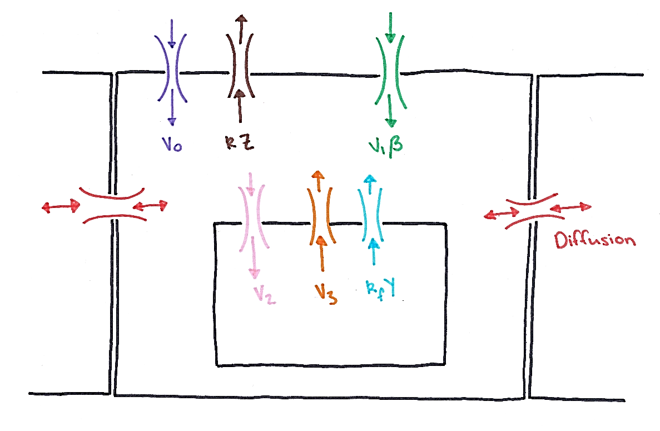

Calcium Store

Now becomes

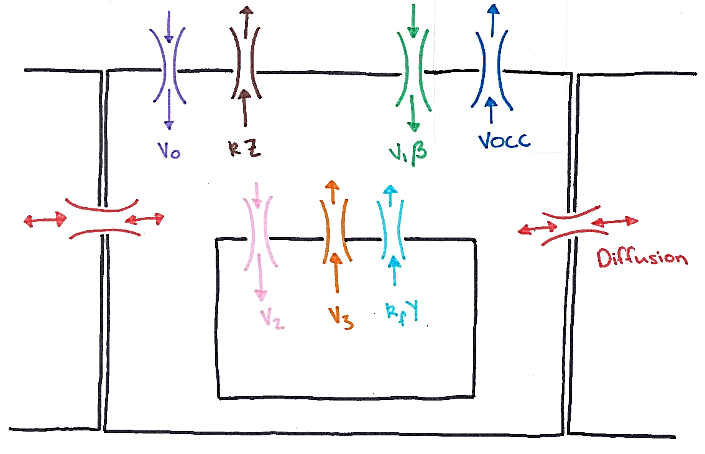

Calcium Store

Goldbeter

# Zero Diffusion Goldbeter

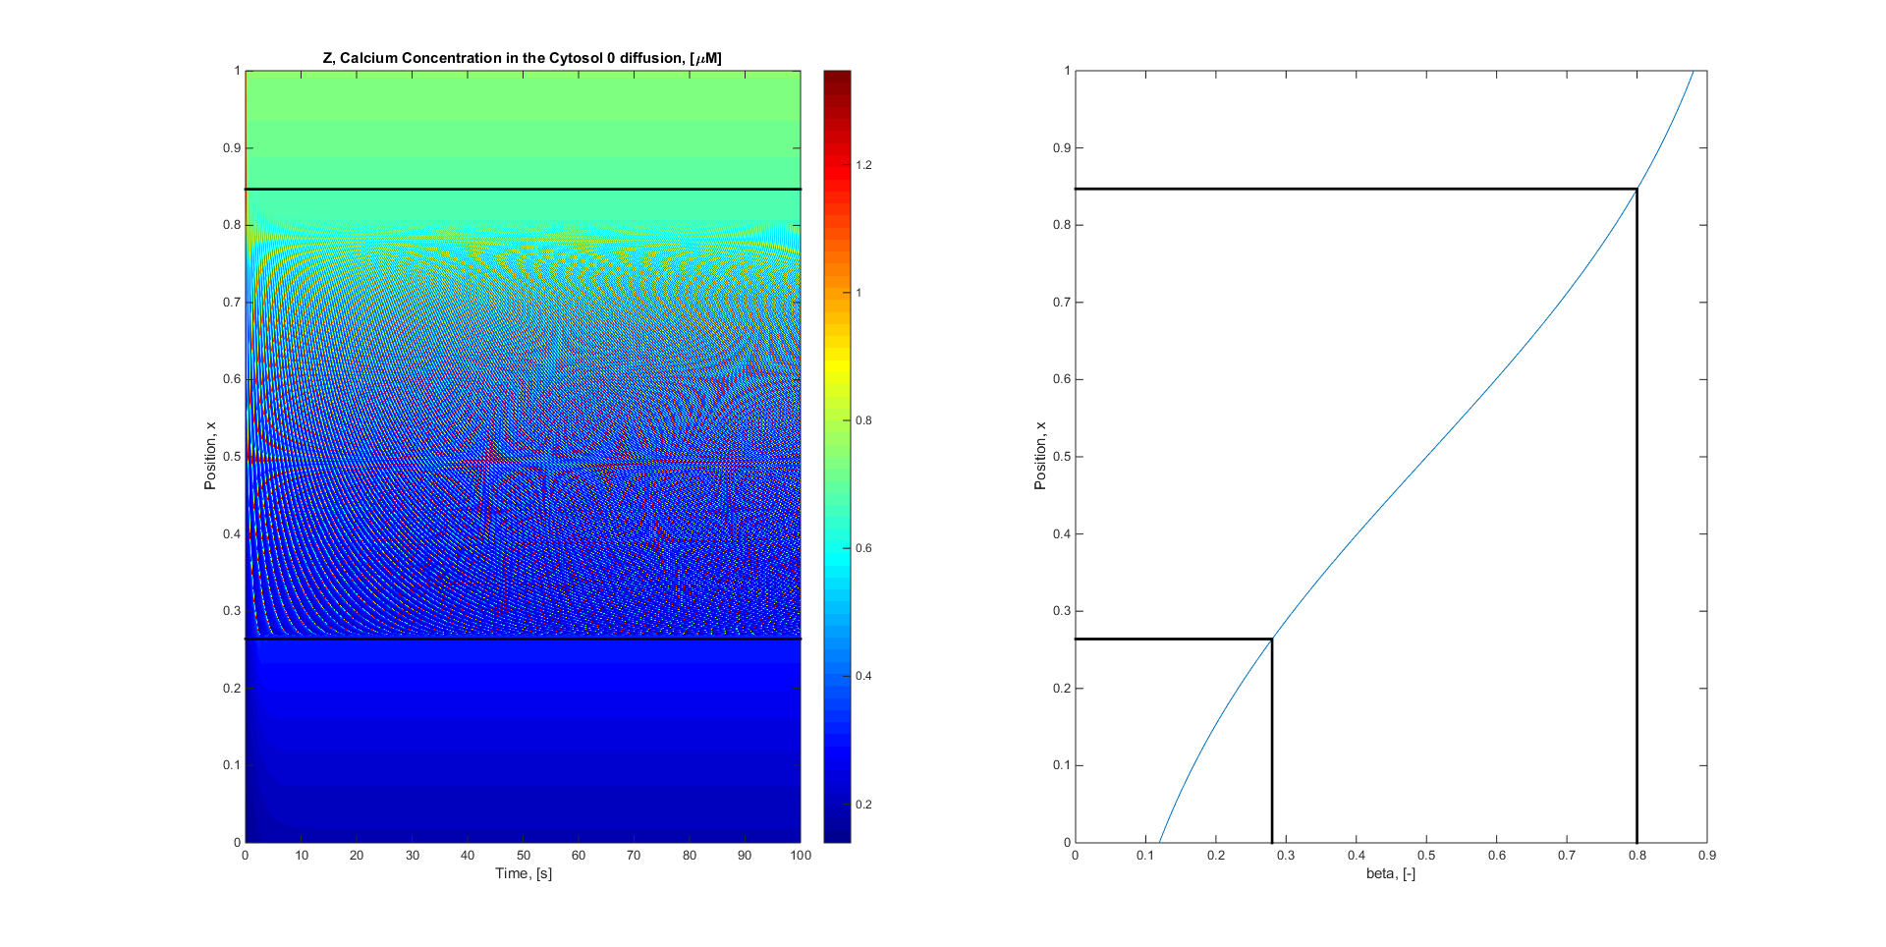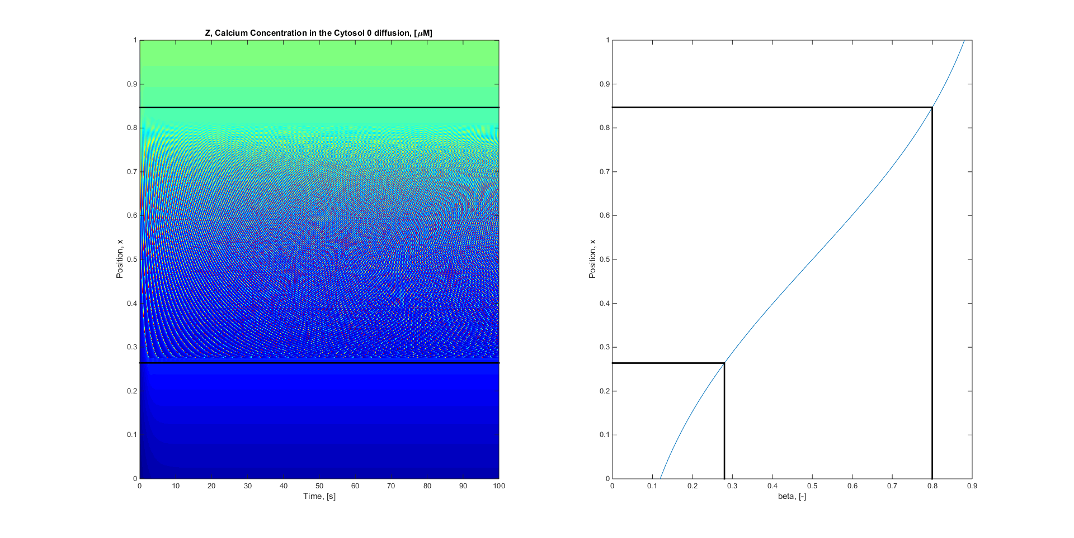

**With VOCC**

# Fickian Diffusion (D = 6e-6) Goldbeter

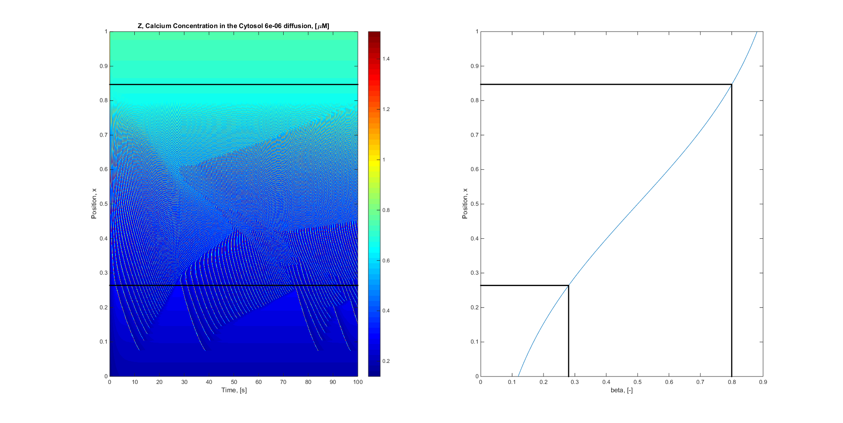

**With VOCC**

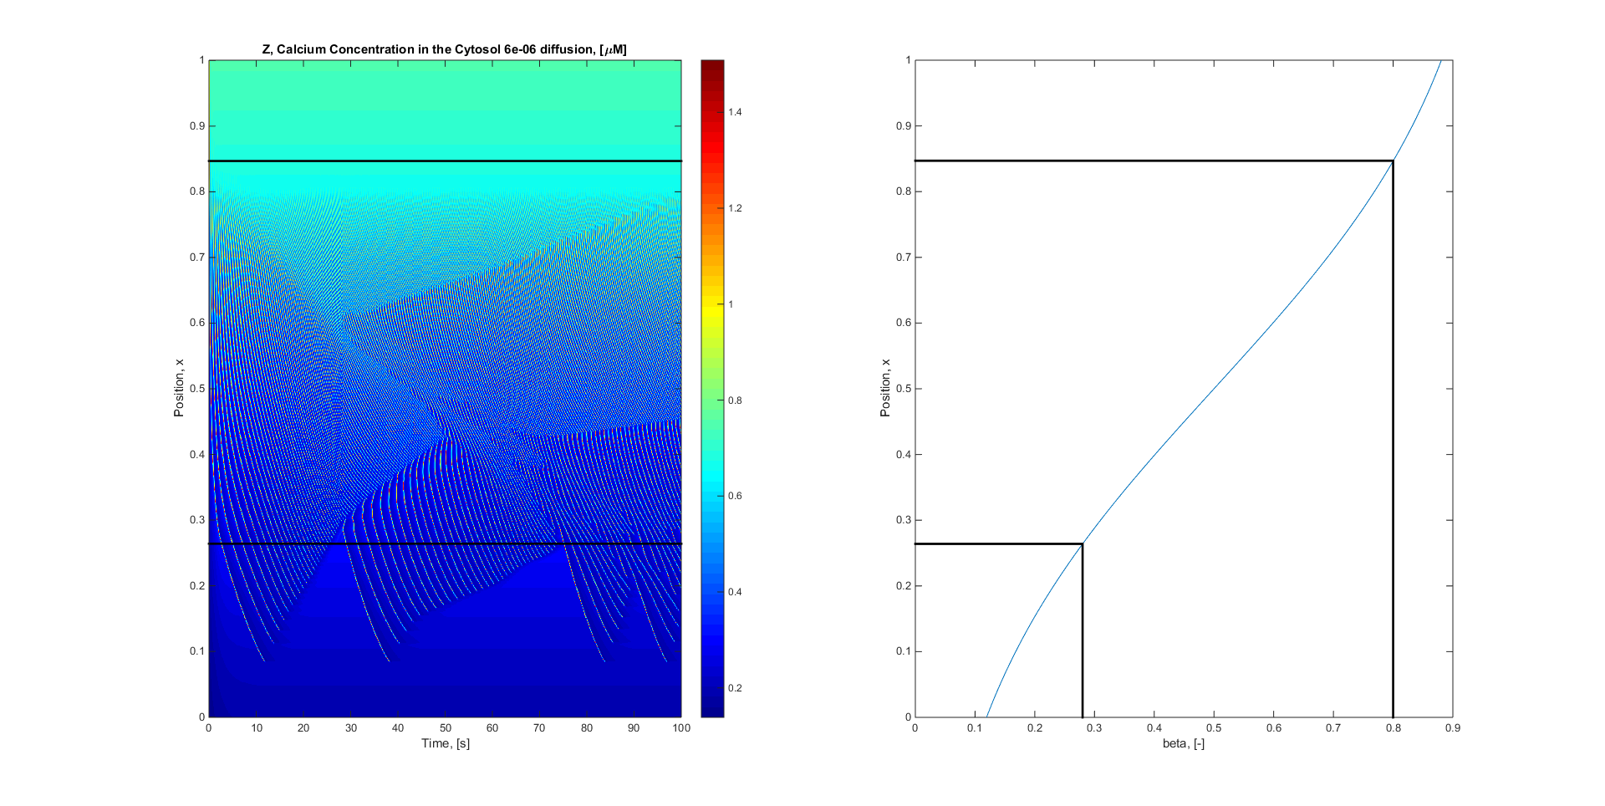

# Electro Diffusion (D = 6e-6) Goldbeter

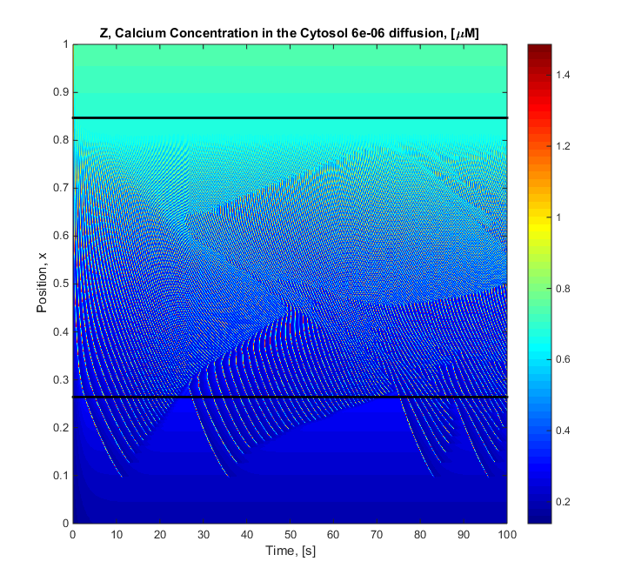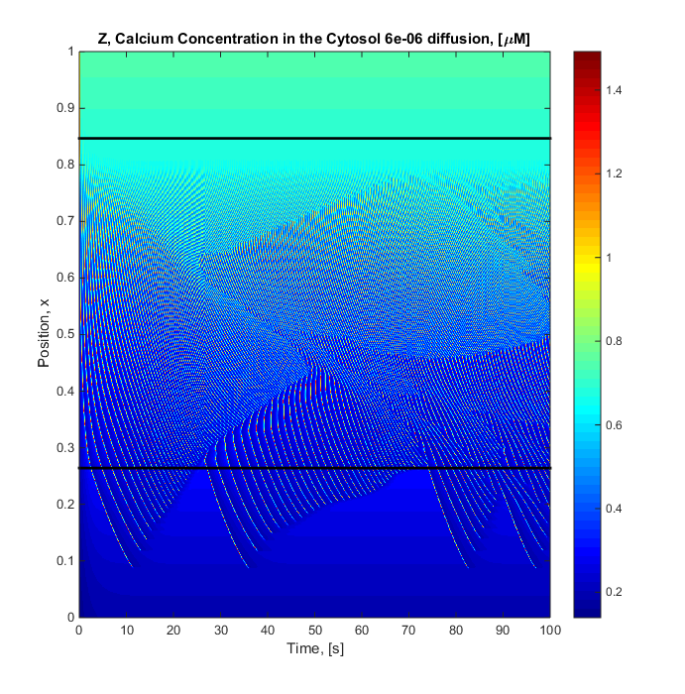

**With VOCC**

Sneyd Model

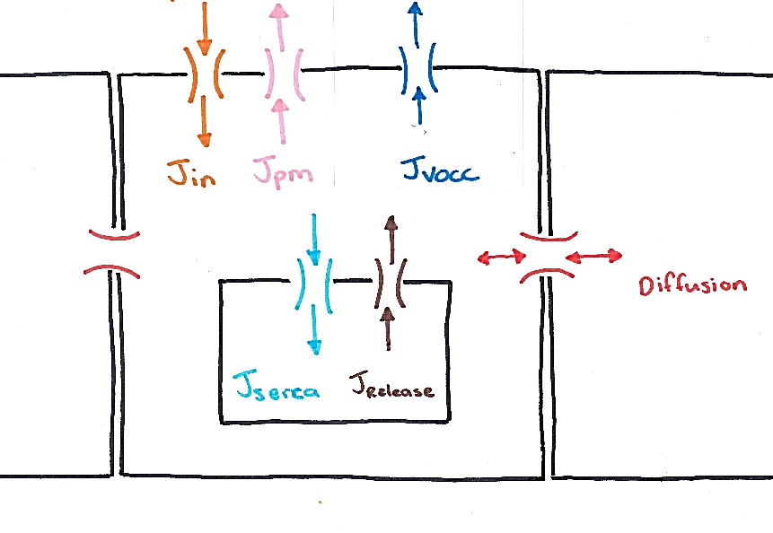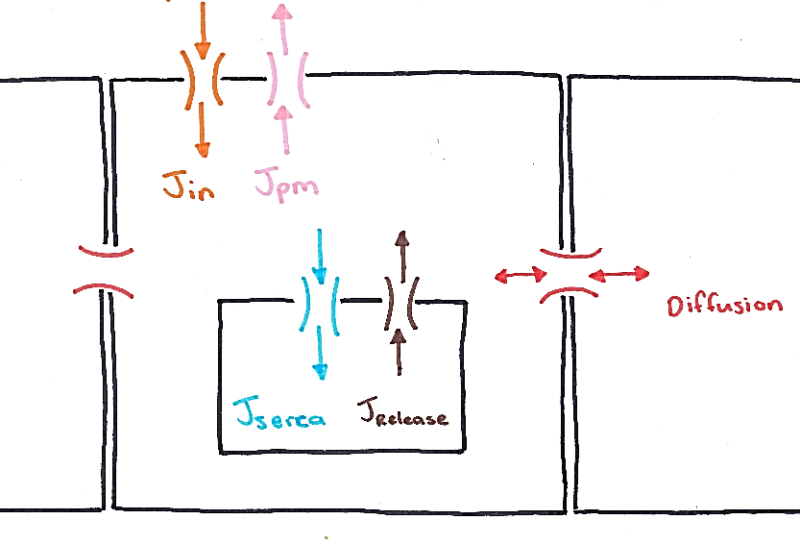

Make

|  |  |
| --- | --- |
|  | 1.2x10-4 M mV-1s-1 |

Factor of 10 times less than before

# Zero Diffusion Sneyd

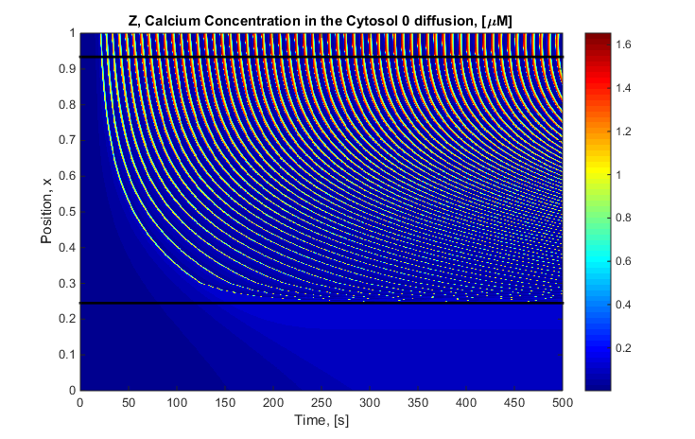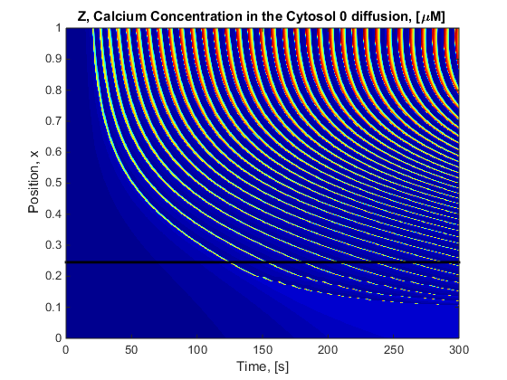

**With VOCC**

# Fickian Diffusion (D = 6e-6) Sneyd

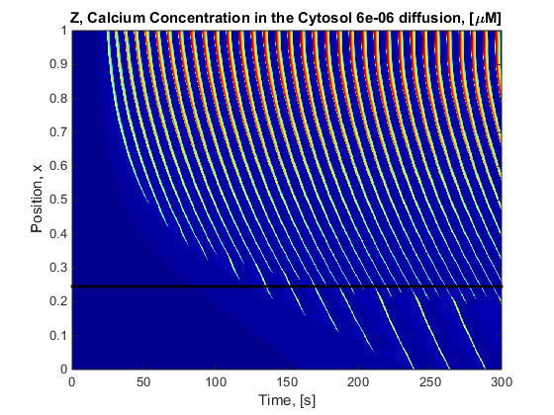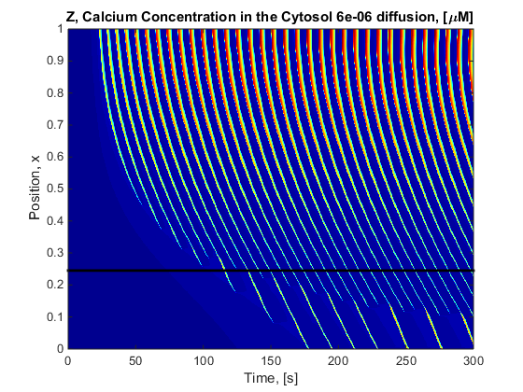

**With VOCC**

# Electro Diffusion (D = 6e-6) Sneyd

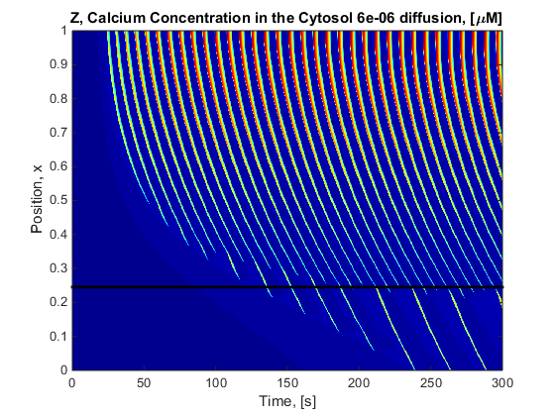 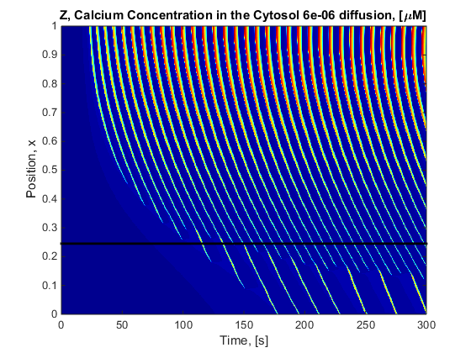

**With VOCC**